 | Briefing  Published September 12, 2025

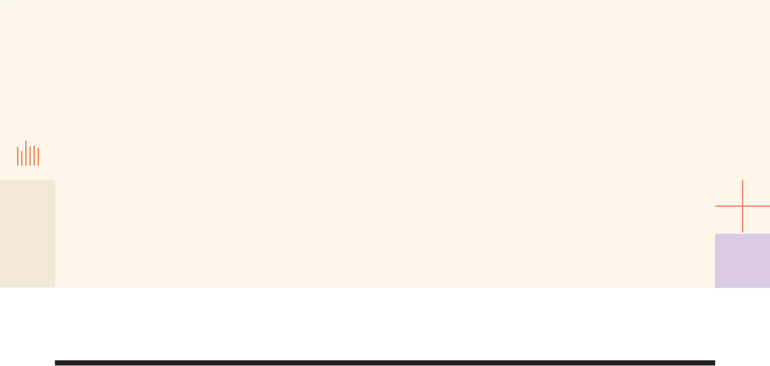

impactglobalhealth.org

The ripple effect: how global health R&D delivers for everyone

Briefing for advocacy and communications partners
Impact Global Health
Please note that the report will be published on September 22, 2025 and is under embargo until then. The URL will not be live until then.

What is this report about?
Global health R&D delivers extraordinary returns for everyone: saving lives, strengthening economics and accelerating scientific progress. This report builds on our May 2024 findings showing that every $1 invested in neglected disease R&D generates $405 in societal return, and dives deeper into the investment case for high-income countries (HICs).
We show how smart, sustained investments in global health R&D create returns that are truly global – delivering health and economic progress for HICs. We examine how much government funding from HICs has gone to global health R&D, how much of it stays within HICs, and the macroeconomic and scientific gains it leads to. We explore the link between R&D and real-world impact, spotlighting case studies that show how innovations developed for LMICs have gone on to help HIC populations, proving that smart, sustained investment pays dividends globally and locally.

What new data is available?
We have calculated
- the total investment each HIC has made in global health R&D between 2007 and 2023
- how much of that investment remained within high-income countries
- how much of that investment remained within the original funding country
- how much each HIC country received in investment from other HICs
- the amount of economic growth within that country driven by this investment
- the jobs generated
- the patents filed
- and the short- and long-term private sector investment catalysed by the public funding*
*short-term is typically within a year, and long-term over a decade
All the data is available in an interactive map hosted on the digital report website at https://www.impactglobalhealth.org/insights/report-library/ripple-effect
You can view the total investment figures at a glance as you scroll across the globe, you can open a fly-out table to see the full breakdown of investment listed by country, and you can click on each country within that table for the economic growth numbers per country.
Each country has its own URL so it is easy to share a country-level view with specific audiences. For example, this is the United States https://www.impactglobalhealth.org/insights/report-library/ripple-effect?map=true&country=USA

What are the key messages?
1. Investing in global health R&D delivers extraordinary economic returns while advancing health equity
Investing in global health R&D generates remarkable multiplier effects: $71 billion in high-income country (HIC) government funding from 2007-2023 has catalysed $511 billion in GDP growth, created 643,000 jobs, and sparked 20,000 patents. Whilst 90% of this funding has been concentrated in HIC institutions, the investments have delivered life-saving innovations that work across borders. Yet, in the current geopolitical climate, traditional funders face pressure to reduce these investments. Scaling back now would not only jeopardise progress in saving lives globally, but it would also forfeit one of the most efficient drivers of domestic innovation and economic growth.
2. Innovations cross borders - with dual benefits for LMICs and HICs
We’ve identified at least 22 health innovations originally developed for use in low- and middle-income countries (LMICs) that have delivered unexpected benefits to HICs. These include vaccines, diagnostics, delivery platforms, and treatments. The AS01 adjuvant developed by GSK, for example, was initially created for the RTS,S malaria vaccine, but has proved pivotal in the development of the Shingrix and RSV vaccines, which are now widely administered in HICs. AS01 is also currently being investigated for use in new tuberculosis vaccines, including M72, a potential game-changer in the fight against antimicrobial resistance.
3. Global health R&D is a pillar of national security and builds pandemic response capacity
COVID-19 validated decades of investment in global health research. Platforms developed for malaria (ChAdOx1), TB (GeneXpert), and the rVSV-based Ebola vaccine became essential pandemic tools and helped pioneer a faster approval process. Building distributed research and manufacturing capacity isn't simply about equity - it's about creating resilience for when, not if, the next pandemic emerges from regions with limited surveillance. The speed of our response to the next pandemic will depend on what we invest today. Protecting lives tomorrow means sustaining discovery now.

How much HIC funding stays within HICs?
Of the $71 billion invested by HICs in global health R&D between 2007 and 2023, 90% ($64 billion) remained in HICs, and most remained within its country of origin: 76% of all HIC funding went to recipients in the same country that provided it. Cross border funding flows between HICs and, especially, funding from the European Commission to EU member states, meant that some countries received more funding than they themselves provided.
Only around 10% of funding flows directly from HIC governments to LMICs. South Africa is by far the largest recipient of this direct funding, receiving 33% of the total, with the next largest recipients – Costa Rica, Brazil, Uganda, Peru and Gambia – all receiving 5% each.
The small share of funding going directly to LMICs reinforces the importance of the role played by Product Development Partnerships (PDPs) and intermediary organisations like the European and Developing Countries Clinical Trials Partnership (EDCTP) and the Coalition for Epidemic Preparedness Innovations (CEPI) which, together, receive 15% of HIC public funding and channel a larger share of it – about 22% of the total – onward to the LMICs in which they work.

Why does most funding remain in HICs?
There are several structural reasons why the majority of global health R&D funding from HICs remains within their borders. Much of this investment is routed through domestic institutions (including universities, government research agencies, and nonprofit organisations), that already have the infrastructure, capacity, and track record to receive and manage large-scale public grants. Procurement rules, risk assessments, and reporting standards often favour established entities within donor countries, creating additional barriers to fund disbursement beyond HICs. Eligibility requirements further reinforce this pattern by mandating or strongly encouraging the involvement of researchers or institutions based in the funding country.
In many cases, HIC governments fund research and product development with a global mandate but contract it out to domestic entities. These institutions may collaborate internationally or develop tools for diseases primarily affecting LMICs, but the funding itself remains in the originating country - along with associated jobs, infrastructure investment, and indirect economic benefit. This is particularly the case for basic research, which is the focus of the US National Institutes of Health (NIH), comfortably the largest single funder of global health R&D. Because basic research doesn’t involve testing medicines on patients it can, and typically does, take place at universities and research institutions in the funding nation.
At the same time, some LMIC institutions face challenges in meeting donor requirements for grant-making, limiting their eligibility for direct funding.

What domestic returns do HICs see from investing in global health R&D?
Our research shows that the vast majority – 90% – of funding from HIC governments into global health R&D goes to HIC institutions, although those institutions may then further flow funding or goods onto LMICs. This funding fuels local economies, boosting GDP and creating high-quality research jobs that ripple into other sectors.
We estimate the $64 billion in R&D funding retained by HICs to generate around $511 billion in economic activity. The US alone is projected to generate $387 billion in economic impact from its R&D investments. For ‘Team Europe’ – EU Member States along with the European Commission itself – the figure is almost $58 billion.
Funding brings higher levels of economic activity that bring more jobs. These jobs, themselves, stimulate more economic activity. We estimate the $64 billion to directly or indirectly generate 643,000 total jobs – the indirect jobs being created through the spending power and economic activity of those directly employed in R&D.
Government spending ‘crowds in’ private sector co-investment by providing a steady stream of new ideas on which the private sector can capitalise. Government grants often provide essential funding to move projects through the riskiest early clinical phases, which then attract private capital to complete product development after proof-of-concept.
We estimate that the $64 billion invested by HIC governments has already catalysed around $62 billion in private R&D, with the potential to grow to $359 billion over the coming decade.
It’s hard to pin down exactly how many patents will result from global health R&D investment. The patenting process is slow, and organisations that are already good at innovating tend to both receive more funding and file more patents, so it can be difficult to determine whether extra funding is the cause or the effect of an organisation’s ability to generate new ideas. However, we estimate investments from HICs could yield around 20,000 patents – driving innovation not just in health but across the wider economy.
What spillover effects does innovation have?

Many innovations initially developed, trialled, or approved for LMICs have ultimately benefited populations in HICs in various ways: including faster and more cost-effective vaccine development, stronger pandemic preparedness, rapid point-of-care diagnostics to reduce waiting times, and broader access to technologies such as affordable and long-acting contraceptives now also used in high-income settings. The report lists 22 innovations to illustrate the broader health, economic and societal benefits of investing in global health R&D, and four case studies covering vaccine adjuvants, contraception, the Covid-19 response and repurposing past innovations to accelerate development which leverages existing safety and toxicity data.

What implications does the report suggest for the global health R&D ecosystem of the future?
Whilst the concentration of R&D investment in HICs has delivered significant returns, this model is reaching its limits. The next phase of global health R&D requires a deliberate transition toward more distributed capacity, not despite the economic benefits to HICs, but to sustain and amplify them. It is in the interests of both HIC and LMIC governments to strengthen this ecosystem further. The report looks at empowering LMICs through investment in local and regional R&D, rethinking how global health R&D is financed, and the critical role PDPs can play in strengthening the future ecosystem.

What are the calls to action?
The report calls for three key actions:
- Protect and expand current investments
HICs receive substantial economic and security returns from global health research and development: each dollar invested creates high-technology employment, advances adaptable platform technologies that can be redeployed quickly in crises, fosters university-industry collaboration, and generates significant downstream market activity. Maintaining and, where possible, expanding HIC funding is essential for national competitiveness and global health security.
- Invest in LMIC-led R&D to build global resilience
Greater investment in LMIC-led R&D that strengthens local research capacity, infrastructure, and regulatory systems unlocks innovation, creates jobs, and accelerates access to life-saving tools. It also helps detect and contain emerging threats before they spread. In a deeply interconnected world, investing in LMIC-led R&D is a critical strategy for building shared resilience. Empowering PDPs and intermediaries to build capacity in LMICs can help shift the model from one-way technology transfer to true partnership anchored in resilient, locally driven innovation systems.
- Reap the rewards well into the future
Reducing investments in global health R&D now would undermine present and future health and economic gains, for LMICs as well as HICs. To sustain these benefits into the future, donors must maintain their investment and adopt partnership models and innovative financing approaches that amplify impact.

